CITY OF CANFIELD

2023 Stick and Limb Pick- Up Quadrant Map

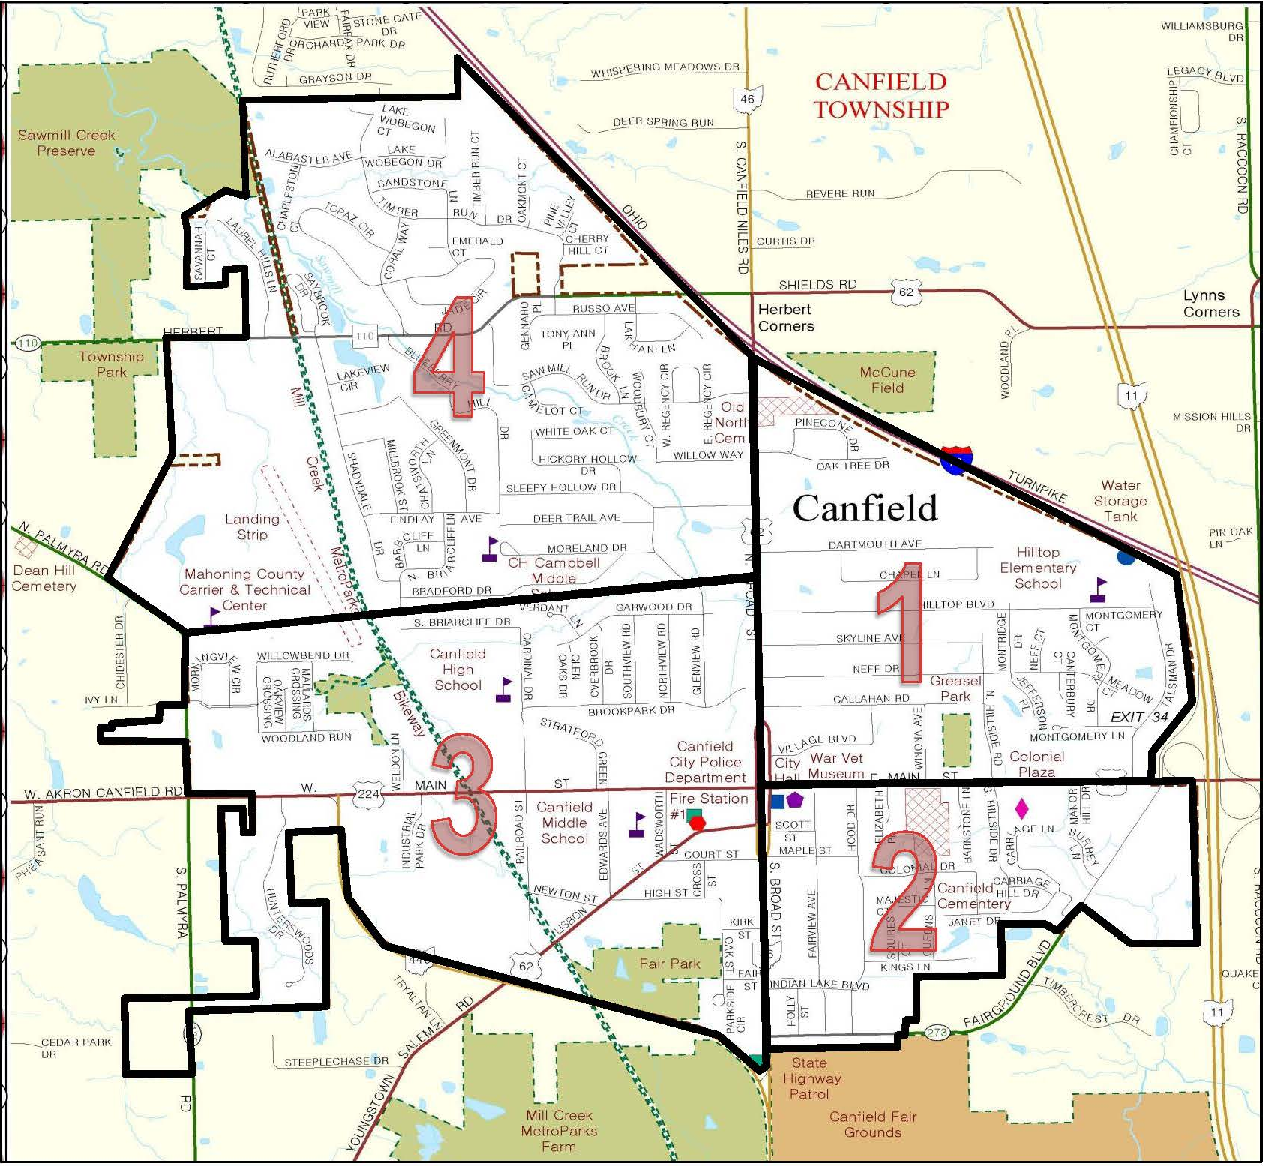

QUADRANT STREET LISTING
QUADRANT- 1  NORTHEAST  Week of April 2, 2023 | QUADRANT -2  SOUTHEAST  Week of April 9, 2023 | QUADRANT- 3  SOUTHWEST  Week of April 16, 2023 | QUADRANT- 4  NORTHWEST  Week of April 23, 2023
Broad Street, North (Odd numbered addresses – East Side) | Broad Street, South (Odd numbered addresses – East side) | Broad Street, North (Even  numbered addresses, 264 and lower) | Alabaster Drive
Callahan Road | Carriage Hill Drive | Broad Street, South (Even  numbered addresses – West Side | Barbcliff Lane
Canterbury Court | Colonial Drive | Briarcliff, South | Blueberry Hill Drive
Chapel Lane | Elizabeth Place | Brookpark Drive | Bradford Drive
Dartmouth Avenue | Fairground Boulevard | Cardinal Drive | Briarcliff, North
Hillside Drive (North) | Fairview Avenue | Court Street | Broad Street, North (Even  numbered addresses, 350 and higher)
Hilltop Boulevard | Hillside Drive, South | Cross Street | Camelot Court
 | Holly Street | Edwards Street | Charleston Court
Main Street, East (Even  numbered addresses – North Side | Hood Drive | Fair Street | Chatsworth Lane
Meadow Court | Indian Lake Blvd. | Garwood Drive | Cherry Hill Court
Montgomery Drive
 | Janet Drive | Glenview Road– 251 and lower | Coral Way
Montridge Drive | Kings Lane | High Street | Deer Trail Ave
Neff Court | Main Street, East (Odd numbered  addresses – South Side | Kirk Street | Emerald Court
Neff Drive | Majestic Court |  | Findlay Ave
Oak Tree Drive | Manor Hill Drive | Lisbon Street | Glenview Road (addresses 260  and higher)
Pine Cone Drive | Maple Street | Main Street, West | Greenmont Drive
Skyline Ave | Queens Lane | Mallard Crossing | Herbert Road
Talsman Drive | Scott Street | Morningview Circle | Hickory Hollow Drive
Village Blvd | Squire’s Court |  | Jade Circle
Winona Ave |  | Newton Street | Lake Wobegon Drive/ Court
 |  | Northview Road | Lakeview Circle
 |  | Oak Street | Lakhani Lane
 |  | Oakview Crossing | Laurel Hill Lane
 |  | Overbrook Drive | Millbrook Street
 |  | Palmyra Rd. North (6971, 6997,  7041, 7049) | Moreland Drive
 |  |  | Oakmont Court
 |  | Preserve Boulevard | Pine Valley Court
 |  | Railroad Street | Regency Circle, East & West
 |  | Southview Road | Russo Avenue
 |  | Stratford Green | Sandstone Lane
 |  | Verdant Lane | Savannah Court
 |  | Wadsworth Street | Saw Mill Run
 |  | Willowbend Drive | Shadydale Drive
 |  | Woodland Run | Sleepy Hollow Drive
 |  |  | Stonybrook Lane
 |  |  | Timber Run Court
 |  |  | Timber Run Drive
 |  |  | Tony Ann Place
 |  |  | Topaz Circle
 |  |  | White Oak Court
 |  |  | Willow Way
 |  |  | Woodbury Court

